CORE JAVA
Development tools include Java compiler (javac.exe) and Java interpreter (java.exe). These tools are required to prepare a Java application for execution.
Java Virtual Machine (JVM) executes a Java application using certain specific libraries and files provided by JRE. JVM is the actual runtime in which a Java application executes.
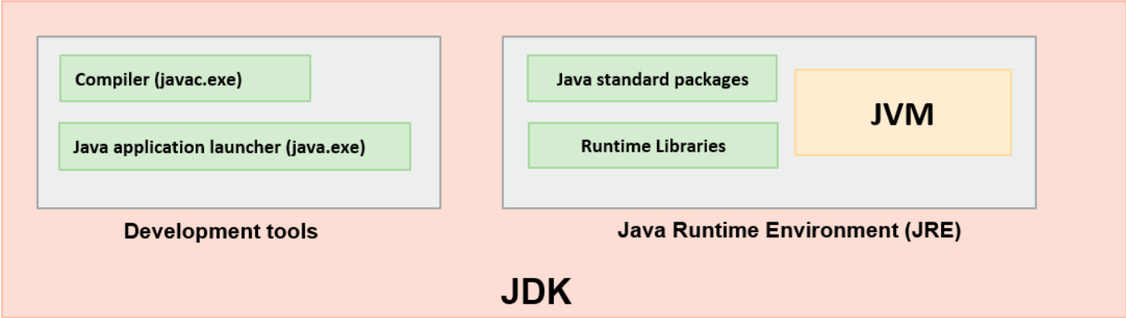
Note: In JDK 11 onwards there is no Java Runtime Environment (JRE).
Why set Java path:
We know that the Java program is executed inside the JVM. So, in any platform like windows, if we want to execute a Java program we should have OpenJDK and we should tell the windows where the Java compiler is located. This is why we have an environment variable called "JAVA_HOME" that has to be allocated with the path pointing to the JDK's bin folder where we can find the Java compiler and all the other executables.
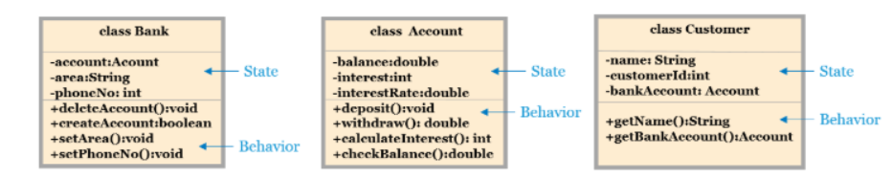
You must have observed; a program has several components and blocks. It has words as well. Some of these words are reserved and have a special meaning in Java, e.g., class, public, void, for, int, static. These words are known as keywords. Currently, Java has 50 keywords.
Not only keywords, but there can be user-defined words to identify different components of a program, e.g., Account, main known as Identifiers. These words are known as Identifiers. Identifiers are names used for identifying components of a program like classes, methods, interfaces, enums, and variables. After defining once, we can use them again to identify corresponding components in the program.
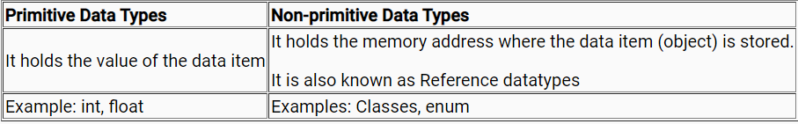
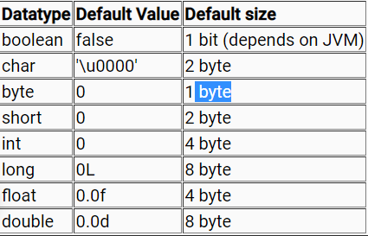
Reference variables point to an object in the memory.
An object can be created and allotted memory using the "new" keyword. The default value of an object is always null.
- Account acct = null;
acct is a reference variable assigned to null, a keyword in Java. The acct reference variable does not point to any object in this case.
- acct = new Account();
The function of the new keyword is to allocate memory for an object (Account object) and assign default values to the member variables. The reference variable acct points to the Account object created in the memory. Just after memory allocation for the object Account() constructor is called.

Abstraction is the process of identifying the essential details to be known and ignoring the non-essential details from the perspective of the user of the system. Abstraction is something which is incomplete.
Encapsulation is hiding the state of Customer class outside this class. In order to hide the internal state from the outside world, we wrap data and code collectively within a single unit, this process is known as Encapsulation. It mandates that all interactions must be performed through an object's methods i.e. only through its behavior.
When the HomeLoan subclass is created, the superclass, i.e., Loan class constructor will also be executed. Let us see this with a sample code snippet.
- When a subclass instance is created, the order of constructor execution is from the root class constructor in the hierarchy to the subclass constructor.
- Line 1 of main() in the PlotLoan class executes the Loan class default constructor and then the HomeLoan class default constructor and finally PlotLoan class default constructor.
Types of Polymorphism?
Static Polymorphism
- Method overloading
- It uses compile-time binding
- Method invoked is based on the reference type
Dynamic Polymorphism
- Method overriding
- It uses late binding or runtime binding
- Method invoked is based on the object type
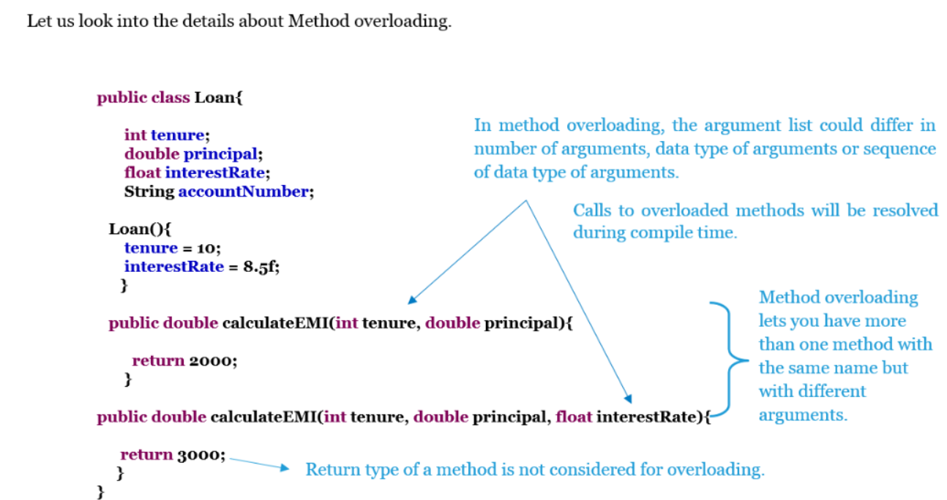
constructors can be overloaded (Parameter and Parameter less constructor)
- //calculateEMI overloaded methods
- public double calculateEMI(int tenure, double principal){
- double simpleInterest = (principal*interest*tenure) / 100;
- return (simpleInterest+principal)/tenure;
- }
- public double calculateEMI(double principal, int tenure){
- double simpleInterest = (principal*interest*tenure) / 100;
- return (simpleInterest+principal)/tenure;
- }
- public double calculateEMI(int tenure, double principal, float interest){
- double simpleInterest = (principal*interest*tenure) / 100;
- return (simpleInterest+principal)/tenure;
- }

- Loan ob;
- HomeLoan h1 = new HomeLoan();
- VehicleLoan v1 = new VehicleLoan();
- ob = h1;
- ob.calculateEMI(200000);
- ob = v1;
- ob.calculateEMI(300000);
- Invoking an overridden method with parent class reference will invoke the method of the child class. JVM calls a method based on the type of the object, not the reference. This decision is taken at run time and hence this is known as dynamic binding or dynamic dispatch method.
- In the child class, the parent class methods and overridden methods can be called with the parent class reference variable.
- Methods defined only in the child class cannot be called using the parent class reference.
- Static variables are global variables that all the objects of a particular class share
- The static keyword is used before
  - Variables
  - Methods
  - Block of code
  - import statement (will be explained in later sections)
- A method or a variable which is static can be called directly by using its class name rather than creating an object reference of that class
- A static block gets executed only once, irrespective of how many instances created for that class
Note: The main method in JVM does not have an instance to call. So, it calls by the class name.
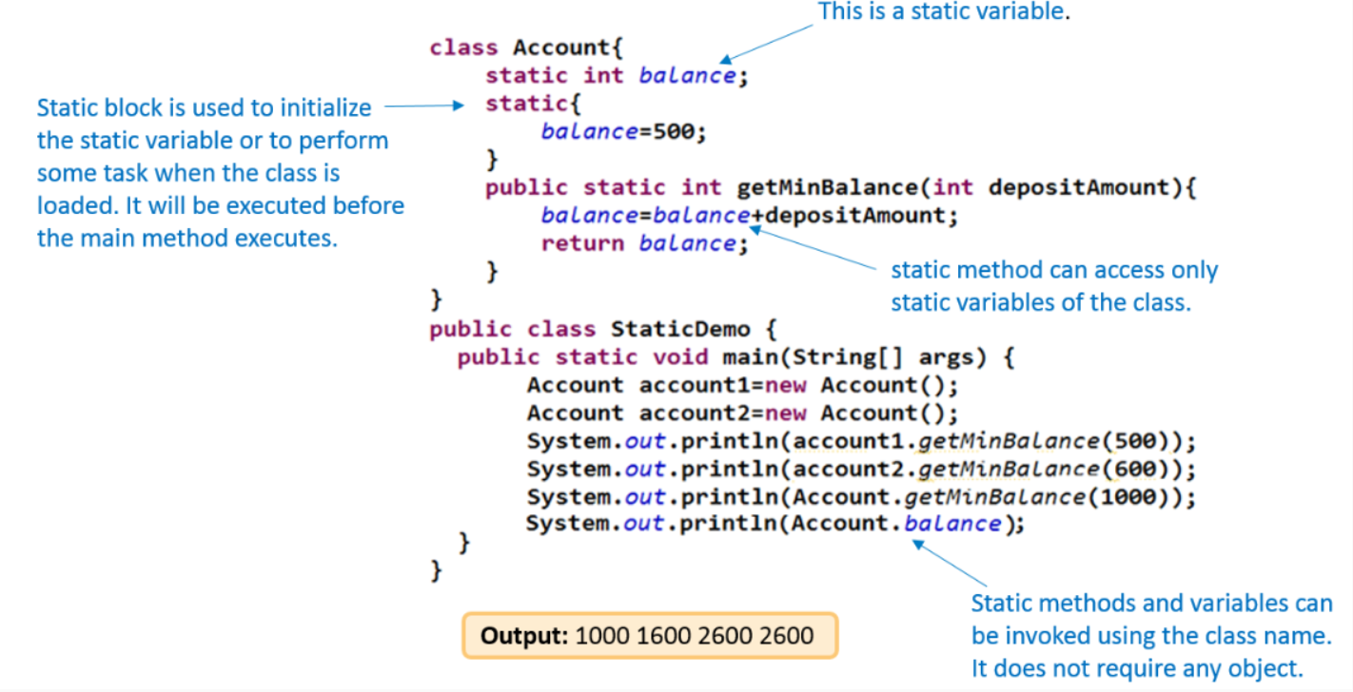

Varargs
We use an array to pass a random number of values to a method. For this, we first create an array, add the values in it, and then call the method. But varargs feature helps to automate and hide the process.

- return_type method_name(data_type... variable){ //Varargs declaration
- statements;
- }

- The three periods after the parameter's data type shows that it can be passed as an array or sequence of arguments.
- Java internally uses an array to process the variable arguments.
- varargs is better than overloading as it can take zero or any number of arguments.
- Only one varargs argument is allowed in a method.
- In case of more than one argument then varargs should be the last argument of the method.
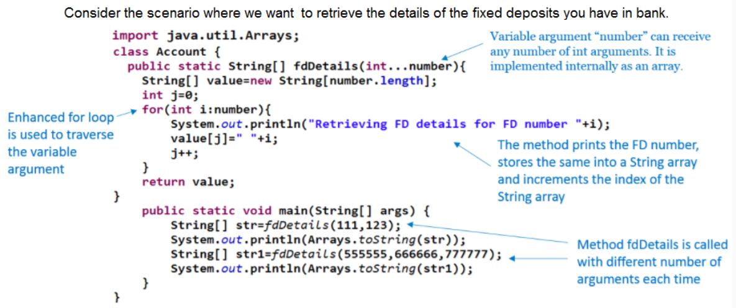
- Since enums are reference data types, like class or interface, and hence, we can define constructors, methods, and variables in an enum.
- The constructor for an enum type must have default or private access. But the constructor cannot be invoked using the new operator.
- enum DAY{
- SUNDAY(1),MONDAY(2),TUESDAY(3),WEDNESDAY(4),THURSDAY(5),FRIDAY(6),SATURDAY(7);
- private int value;
- private DAY(int value){
- this.value=value;
- }
- public int getValue(){
- return this.value;
- }
- }
- public class UserInterface{
- public static void main(String[] args){
- //printing all constants of an enum
- for(DAY day:DAY.values())
- System.out.println("Day:"+day.name()+" Value:"+day.getValue());
- }
- }

- An abstract class cannot be instantiated using the new keyword.
Abstract
- The subclass of an abstract class can be only instantiated if it provides the implementation for all the abstract methods.
- If a class has at least one abstract method, then the class must be declared as abstract.
- If the subclass does not implement all the abstract methods, then the subclass must also be declared as abstract.
- An abstract class can also have concrete methods i.e. methods with implementation.
- An abstract class reference can be assigned an object of its subclass, thereby achieving run-time polymorphism.
Interface
- An interface defines a contract for a class.
- Objects can't be created for interface and an interface cannot have private or protected members.
- In an interface, all methods are implicitly public and abstract and variables are implicitly public, static, and final.
- The class which implements the interface has to provide definitions for all abstract methods.
- If at least one abstract method of the interface has not been overridden by the class that implemented the interface, make it abstract.
- Inheritance is possible in an interface and it supports multiple inheritance.

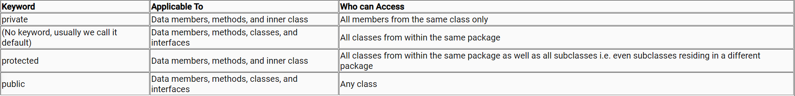
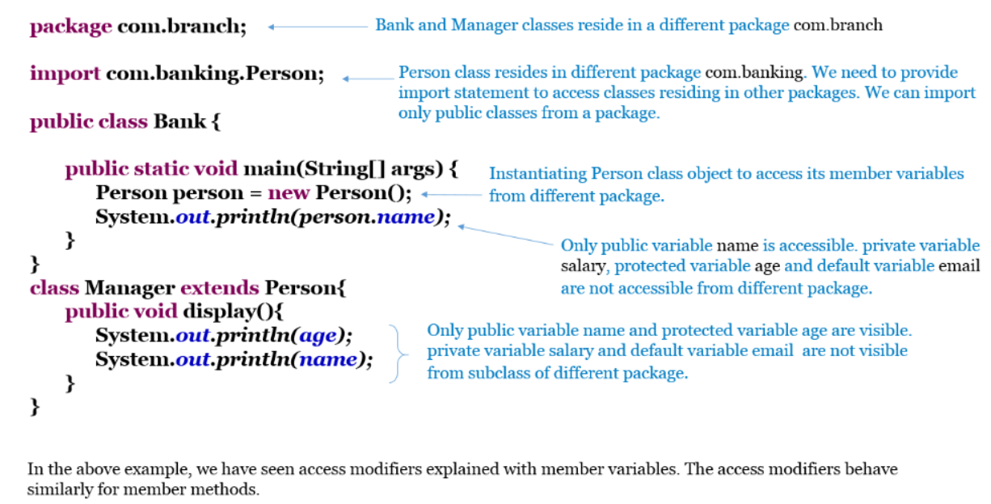
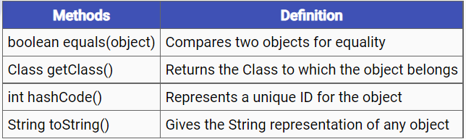
equals() method
- By default equals() from the Object class uses memory address to compare Object. (just like ==)
- According to the business requirement, this equals() method inherited by any class from the Object class can be overridden.
hashCode() method
- In Java, the hash table data structure is used in many classes for improving performance.
- To store/handle an object in the hash table, a hash code (32 bit number) is generated by the hashCode() method.
- Default implementation of hashCode() derives hash code value by using the memory address of the object.
- hashCode() from object class can be overridden according to the business requirement.
- String Class's overridden hashCode() derives hash code by taking the content of the string.
hashCode-equals contract:
- If object1 and object2 are equal, their hash code values should be the same.
- If the hash code values of object1 and object2 are the same, it does not prove that the objects are equal.
- If only the equals method is overridden for objects, then their hashCode will be different. This violates the hashCode-equals contract. To maintain this contract both methods equals and hashCode should be overridden appropriately for equality.
- Java collections cannot store primitive types. It can store only objects.

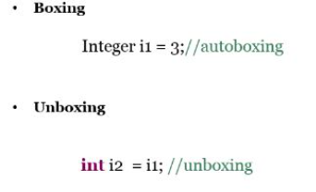
Autoboxing features help avoid explicit calls to the constructor
Similarly, unboxing avoids an explicit call to methods like intValue which returns the value of the Integer as an int
Best Practices:
- Primitive types are faster than wrapper classes and they are used to prevent runtime exceptions as they are not nullable
- As Wrappers are classes, they can be less efficient than a primitive that stores only a single value
- Whenever possible, we must use primitive types since they are much efficient than wrapper classes
- Comparing Wrappers using == is wrong because it compares the reference value and not the value represented by the Wrappers.
Strings can be created by applying one of the following methods:
String username = "Jeena"
String username = new String("Jeena")
- String username = "Jeena"
Here username is represented as a String literal. String literals are created in a pool section of the heap memory. For example, if we create another String literal: String name = "Jeena", then both name and username point to the same literal in the pool.
- String username = new String("Jeena")
Here username is represented as a String object. If we create another String: String name = new String("Jeena"); then both name and username point to two different objects in the memory.
Always remember that string literals are not eligible for garbage collection throughout the application. On the other hand, String objects can be garbage collected.
- Applying == on two Strings compares the address of the two Strings.

- String username = new String("Jeena");
- String name = new String("Jeena");

- System.out.println(username== name)

- will print false because both the references point to different addresses.
- Applying the equals method on a String compares the content of the two Strings.

- System.out.println(username.equals(name))

- will print true
- However, in case of String literals, applying == and equals method in the above scenarios will print true.

- StringBuffer object is mutable i.e. it represents a String that can be changed without creating a new object.
- StringBuffer's capacity can be dynamically increased even though its initial capacity is specified.
- The API's of StringBuffer is synchronized (synchronized keyword is not covered in this course)
- StringBuffer is a final class and it is available in java.lang package
Some of the methods of StringBuffer class are append(), insert(), delete(), reverse().
StringBuilder is the non-Synchronized version of the StringBuffer class.
- It is used when we do not require thread-safety (thread safety is not covered in this course)
- String and StringBuffer classes are slower than StringBuilder
- It contains all the methods of the StringBuffer class
- ​​​The StringBuilder in Java provides a mutable sequence of characters. The StringBuilder is used as an alternative to the String class in Java because of its mutability.
Inner Class
Java allows a class to be defined within another class. These are called Nested Classes. Classes can be static which most developers are aware of, henceforth some classes can be made static in Java. Java supports Static Instance Variables, Static Methods, Static Block, and Static Classes. The class in which the nested class is defined is known as the Outer Class. Unlike top-level classes, Inner classes can be Static. Non-static nested classes are also known as Inner classes.
An instance of an inner class cannot be created without an instance of the outer class. Therefore, an inner class instance can access all of the members of its outer class, without using a reference to the outer class instance. For this reason, inner classes can help make programs simple and concise.
Remember: In static class, we can easily create objects.
Differences between Static and Non-static Nested Classes
The following are major differences between static nested classes and inner classes.
- A static nested class may be instantiated without instantiating its outer class.
- Inner classes can access both static and non-static members of the outer class. A static class can access only the static members of the outer class.
- // Java program to Demonstrate How to
- // Implement Static and Non-static Classes

- // Class 1
- // Helepr class
- class OuterClass {

- // Input string
- private static String msg = "GeeksForGeeks";

- // Static nested class
- public static class NestedStaticClass {

- // Only static members of Outer class
- // is directly accessible in nested
- // static class
- public void printMessage()
- {

- // Try making 'message' a non-static
- // variable, there will be compiler error
- System.out.println(
- "Message from nested static class: " + msg);
- }
- }

- // Non-static nested class -
- // also called Inner class
- public class InnerClass {

- // Both static and non-static members
- // of Outer class are accessible in
- // this Inner class
- public void display()
- {

- // Print statement whenever this method is
- // called
- System.out.println(
- "Message from non-static nested class: "
- + msg);
- }
- }
- }

- // Class 2
- // Main class
- class GFG {

- // Main driver method
- public static void main(String args[])
- {

- // Creating instance of nested Static class
- // inside main() method
- OuterClass.NestedStaticClass printer
- = new OuterClass.NestedStaticClass();

- // Calling non-static method of nested
- // static class
- printer.printMessage();

- // Note: In order to create instance of Inner class
- // we need an Outer class instance

- // Creating Outer class instance for creating
- // non-static nested class
- OuterClass outer = new OuterClass();
- OuterClass.InnerClass inner
- = outer.new InnerClass();

- // Calling non-static method of Inner class
- inner.display();

- // We can also combine above steps in one
- // step to create instance of Inner class
- OuterClass.InnerClass innerObject
- = new OuterClass().new InnerClass();

- // Similarly calling inner class defined method
- innerObject.display();
- }
- }
Output
Message from nested static class: GeeksForGeeks
Message from non-static nested class: GeeksForGeeks
Message from non-static nested class: GeeksForGeeks

Exception
In the above case, an exception is generated inside the divide() method. Since the divide() method doesn't take care of it, the exception propagates to its calling environment, which is the main() method. The main() method also doesn't take care of it, and the exception propagates to its calling environment, which is the runtime.
Exception class should be in the last catch block in the catch block hierarchy, but here we have NumberFormatException at the end which is a subclass of the Exception class.

Generic
This approach has some drawbacks:
- Any type of Object (Student, String, Integer, etc.) can be pushed into the record
- If the record is supposed to hold only Books, we cannot restrict it to do so
- Record bookRecord = new Record();
- bookRecord.add(new Book("Java"));
- bookRecord.add(new Student("Mark Smith")); // This will be allowed
- The Object that we get from the record has to be typecasted back to the required type before use
- This typecast is unsafe. The compiler will not check that we are typecasting to the same data type that is present in the record. And so, the cast may fail at runtime.
- Book book = (Book) bookRecord.get(1); // Type casting Object to Book
Since we have added Student record at index 1 the above type cast will fail at the runtime giving ClassCastException. Hence making type cast unsafe.
- class Record<E> {
- private E[] record;
- public E add(E item) {
- // Code to add record item
- }
- public E get(int index) {
- // Code to get record at specified index
- }
- }

- E is the type parameter
- Elements of type E can be added into and retrieved from the Record
- E can be used anywhere inside the Record class

Now our Record class is a generic class.
This allows us to declare Record<Student> studentRecord = new Record<Student>();
Then studentRecord.add(new Student("Mark Smith")) will be allowed but studentRecord.add(new Integer(0)) will give a compilation error.
Also, it will be known to the compiler that studentRecord.get(32) will give a Student. So, no typecasting is required.
- A generic type with primitive type cannot be used. It must always be used with a reference type.
Collection Family
Array cannot grow and shrink dynamically. In addition, they do not have an integrated algorithm for sorting or searching.
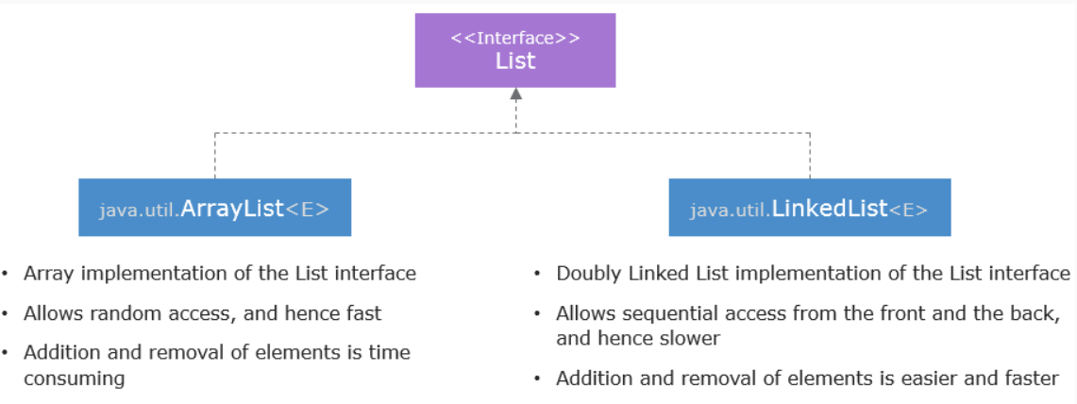
The ListIterator, which is exclusive to lists, is similar to an Iterator. It allows bidirectional traversal and modification of elements.
Apart from the methods provided by List, some methods exclusive to the LinkedList class are:
Name | Description
void addFirst(E e) | Adds the value at the beginning of the list.
E removeLast() | The last element is removed and returned.
E removeFirst() | The first element in the list is removed and returned.
E getLast() | The last element is returned.
E getFirst() | The first element is returned.
void addLast(E e) | Adds the value to the end of the list.

Some of the important methods present in the Map interface are:
Methods | Description
V put(K key, V value) | Adds a mapping on the map.
V get(Object key) | The value corresponding to the specified key in the map is returned.
V remove(Object key) | The mapping for the specified key is removed.
int size() | The number of mappings in the map is returned.
boolean isEmpty() | If the map contains no mapping true is returned.
Set<K> keySet() | A set containing the keys in the map is returned.
Set< Entry<K,V>> entrySet() | A set containing the entries in the map is returned.
Collection <V> values() | A collection consisting of the values in the map is returned.

- //Retrieving the set of Courses by studentID using get() method
- Set<Course> courseSet = studentCourses.get(1001);
- System.out.println(courseSet);

- // Iterating over the set of keys using for-each loop
- Set<Integer> setOfKeys = studentCourses.keySet();
- for(Integer i : setOfKeys) {
- System.out.println(studentCourses.get(i));
- }

- // Iterating over the collection using values() method
- for(Set<Course> courseSet : studentCourses.values()) {
- System.out.println(courseSet);
- }
Choose the right collection based on the requirement to improve performance. Some of the points to be considered are:
- If duplicate elements are not allowed to choose Set otherwise choose List.
- ArrayList is quicker than LinkedList to randomly access elements.
- For quick removal and addition, LinkedList is better than ArrayList.
- Use collections such as TreeMap, TreeSet when elements in the collection are required to be sorted and ordered.
- Use concurrent collections to support concurrent access.

- How to make a class immutable?
  - The class must not be extended. So, either make the class final by converting all the fields final and private and provide exclusive access to any mutable components. Else, make the constructors private and use public static factories to create new objects.
  - Example: Look at the code given below
- class Product {
- private String productCode;
- private String productName;

- private Product(String productCode, String productName){
- this.productCode = productCode;
- this.productName = productName;
- }

- public static Product valueOf(String productCode, String productName){
- return new Product(productCode,productName);
- }
- }

- Memory leaks in Java can be observed through careful code inspection or a debugging tool called heap profiler.

